FIN 545 · WORKSHOP ON FINANCIAL MODELLING
Financial Feasibility & Investment Decision Report
Campus Brew Café
A 30-seat café near Lovely Professional University, Phagwara, Punjab
Item | Detail
Academic Task | Academic Task 1 (30 marks)
Course | FIN 545 – Workshop on Financial Modelling
Faculty | Dr Basit
Programme | M.Com, Lovely Professional University
Roll No. | A15
Members / Registration nos. | Harleen Kaur 12514334
Submission date | 1 October 2026
Companion workbook | FIN545_Cafe_Feasibility_Model.xlsx
LinkedIn pitch URL | www.linkedin.com/in/harleen-kaur-b376a0379
Investment decision | Invest with Conditions
EXCEL FILE LINK | https://github.com/harleenkaur20243/Financial-Modelling.git

Contents
1. Executive Summary
2. Business Opportunity
3. Market & Evidence
4. Operating Model
5. Investment & Funding
6. Assumptions and Key Modelling Decisions
7. Financial Forecast
8. Project Free Cash Flow & Appraisal
9. Break-even Analysis
10. Scenario & Sensitivity Analysis
11. Investment Recommendation
12. Risks & Limitations
13. References
14. Appendix
(Every table in this report is taken directly from the companion Excel workbook. The sheet it comes from is named under each table, so any number can be traced to its formula).

1. Executive Summary
This report evaluates whether a 30-seat café near Lovely Professional University (LPU) in Phagwara is a sound use of ₹29.30 lakh of capital. The café would sell beverages, snacks and meal combos to LPU's student and staff community, which is more than 30,000 students on a campus along the GT Road corridor. The decision to make is whether to Invest, Invest with Conditions, or Not Invest.
The model forecasts ₹39.60 lakh of revenue in Year 1, rising to ₹77.01 lakh in Year 5, as seat usage grows from 2.5 to 4.0 customer groups per seat per day. The café is roughly break-even at EBITDA level in its first year (₹0.72 lakh), turns profitable at the operating level in Year 2, and reaches ₹18.30 lakh EBITDA by Year 5. Measured as a project, free of financing effects, it delivers an NPV of ₹2.03 lakh, an IRR of 15.3% against a required return of 13.3%, and a payback of 4.1 years.

Key results
Metric | Result | What it tells us
Initial investment (Year 0) | ₹29.30 lakh | Equipment, fit-out, licences, deposit and opening cash
Funding mix | 50% debt / 50% equity | ₹14.65 lakh each
Year-1 / Year-5 revenue | ₹39.60 lakh / ₹77.01 lakh | Growth comes from more customers and 5% price rises
Year-5 EBITDA / net profit | ₹18.30 lakh / ₹11.13 lakh | Healthy operating margin once fixed costs are covered
NPV at 13.3% | ₹2.03 lakh | Small positive value created
IRR | 15.3% | 2.0 percentage points above the required return
Payback | 4.1 years | Most cash comes back late in the five-year window
Break-even (Year 1) | 73 customers/day | Projected 75/day, so the cushion is only 2.8%
Pessimistic-case NPV | −₹48.92 lakh | Volume −20%, price −10%, costs +10%
Most sensitive variable | Selling price | A small price shortfall wipes out the NPV
Source: sheets 16_Appraisal, 17_Break_Even, 18_Scenarios, 19_Sensitivity and 20_Dashboard.

Recommendation: Invest with Conditions
We recommend proceeding only if specific conditions are met. The base case clears the hurdle, but narrowly: the NPV is positive by just ₹2.03 lakh on a ₹29.30 lakh outlay (a profitability index of 1.07). The model is also fragile: a price shortfall of only about 1.2%, or a volume shortfall of about 2.0%, would push the NPV below zero. In the pessimistic scenario the café loses money for five years. A project with a thin base case and a deep downside should not receive an unconditional "Invest". The conditions in Section 11 convert the main uncertainties (rent, equipment cost, average bill and early footfall) into things we confirm before and shortly after committing money.

2. Business Opportunity

2.1 The problem
LPU is one of India's largest single-campus universities, with more than 30,000 students plus faculty and staff on a 600-acre campus on the Jalandhar–Delhi GT Road (Source SRC-07). Students are a naturally concentrated, repeat customer base: they eat out frequently, are price-sensitive, and want places to sit, meet and study between classes. At peak hours, seating near the campus gate is limited, which creates space for another affordable, comfortable café.

2.2 The solution
Campus Brew Café is a 30-seat café of about 750 sq ft offering hot and cold beverages, snacks and meal combos at student-friendly prices (average bill about ₹160 before GST). It would run with five staff: a cook, two service staff, a helper and a manager.

2.3 Customer, geography and business model
- Target customers: LPU students, faculty and staff, plus some highway travellers on the GT Road (NH-44) corridor.
- Geography: near LPU, Chaheru, Phagwara, Punjab.
- Business model in one sentence: the project invests about ₹29.3 lakh to provide food and beverages to students and staff in the LPU catchment, earning revenue through per-customer bills.
- Unit of economics: one paid customer visit. Revenue = seats × seat turns per day × days open × average bill.

2.4 Investment rationale and why we chose this project
We considered a highway EV fast-charging hub as an alternative. It has attractive growth stories, but its economics depend on charger technology, grid connection rules, subsidy eligibility and utilisation that are hard to verify quickly, and the vocabulary distracts from the finance. A café has a simple, observable revenue driver (customers), an easily understood cost structure, and a customer base we can reason about. That makes it a better vehicle for a transparent, defendable model, which is the purpose of this assignment. The investment question remains real: a single outlet needs about ₹29 lakh and has several uncertain inputs, so whether it creates value is genuinely open.

3. Market & Evidence

3.1 Research method
Because a new café has no sales history, forecasting from past trends is impossible. We used a capacity-based, driver-based approach: the physical size of the shop sets a ceiling on customers, a utilisation assumption fills it gradually, and each cost is tied to either customers (variable) or time (fixed). External evidence was gathered for the inputs that could be checked against public sources, such as wages, electricity tariffs, interest rates and inflation. Where no reliable source could be found in the time available, we used a documented estimation method and flagged the number as an estimate.

3.2 Evidence quality: what is verified and what is estimated
The table below summarises the evidence. We deliberately separate numbers we confirmed from numbers we estimated, because the strength of a conclusion depends on the strength of its inputs.
ID | Evidence | Value used | Status
SRC-01 | Punjab minimum wages (state notification, via WageIndicator) | Unskilled ₹518.69, semi-skilled ₹553.19, skilled ₹592.84 per day (from 1 May 2026) | Verified
SRC-02/03 | PSERC tariff order (The Tribune, Babushahi) | Commercial ₹6.89–7.75/kWh in FY26; non-residential charges reduced in FY27. Model uses ₹7.2 | Verified
SRC-04 | RBI repo rate (Aug 2026 MPC) | 5.25%; loan priced at repo plus spread = 10% | Repo verified; spread estimated
SRC-05 | India 10-year G-Sec yield (Trading Economics, 15 Sep 2026) | ≈7.1% used as risk-free rate | Verified
SRC-06 | CPI inflation and RBI projection | 4.82% (Aug 2026); RBI FY27 projection 4.6%; used 5% price/cost growth | Verified (inflation)
SRC-07 | Careers360: LPU profile | 30,000+ students, GT Road location | Verified (secondary)
SRC-08 | Corporate tax, Sec. 115BAA | 25.17% | Statutory rate
SRC-09 | FSSAI and shop licences | ₹30,000 set-up; ₹5,000/yr renewals | Estimate
SRC-10 | Café industry cost benchmarks | Food cost 32% + packaging 4% of sales; 7–15 day supplier credit | Estimate (benchmark)
SRC-11 | Supplier price ranges (e.g. IndiaMART) | Equipment ₹8.0L, furniture ₹3.5L, fit-out ₹6.0L, POS ₹0.8L | Estimate
SRC-12 | Local rental market and layout | 750 sq ft at ₹90/sq ft/month; 30 seats; 330 days | Estimate
SRC-13 | Café menu prices near LPU | Average bill ₹160 (before GST) | Estimate
SRC-14 | CAPM inputs (beta, equity risk premium, start-up premium) | Beta 1.0; ERP 7%; start-up premium 5% | Estimate
SRC-15 | Bank MSME loan terms | 50% debt, 5-year tenor | Estimate
Source: sheet 02_Data_Sources. Full URLs and the "action to firm up" column are in the workbook.

3.3 Limitations of the evidence
The most important estimated inputs are rent, equipment and fit-out cost, average bill and seat utilisation. These drive most of the result, and we have not obtained supplier quotations, landlord quotes or competitor footfall counts. We therefore treat the NPV as indicative rather than precise and rely heavily on the scenario and sensitivity analysis to show how wrong an estimate can be before the decision changes. Firming up these four inputs is the first condition of our recommendation.

3.4 Use of AI tools
An AI assistant (Claude, by Anthropic) was used to explain the assignment brief and search for public data (wages, tariffs, rates). Each AI-sourced figure was checked against the sources above or labelled as an estimate. The log of what was asked, what was used, and what was verified is in sheet 03_AI_Research_Log and in Appendix D.

4. Operating Model

4.1 How revenue is built
A café earns money by selling food and drinks. Because no sales history exists, we do not type a sales figure; we derive it from physical capacity. Seats are the ceiling: a café cannot serve more customers than its seats and opening hours allow. Each seat is "turned" several times a day (one group sits, eats, pays and leaves). So:
Customers per year = seats × seat turns per day × days open, and Revenue = customers × average bill.
This is the standard way to forecast hotels (rooms × occupancy), hospitals (beds × occupancy) and restaurants (seats × turns). We chose it because it is defendable: it prevents claiming sales the shop could not physically serve, and the one uncertain input (turns) is visible and testable. We then cross-check it against demand: 75 customers a day in Year 1 is a very small share of a campus community of more than 30,000.
Operating driver | Year 1 | Year 2 | Year 3 | Year 4 | Year 5
Seats (units) | 30 | 30 | 30 | 30 | 30
Seat turns per day | 2.5 | 3.0 | 3.5 | 3.8 | 4.0
Days open | 330 | 330 | 330 | 330 | 330
Customers per year | 24,750 | 29,700 | 34,650 | 37,620 | 39,600
Customers per day | 75 | 90 | 105 | 114 | 120
Average bill (₹) | 160 | 168 | 176 | 185 | 194
Revenue (₹ lakh) | 39.60 | 49.90 | 61.12 | 69.68 | 77.01
Source: sheets 05_Operating_Drivers and 07_Revenue_Model.

4.2 Pricing and utilisation logic
- Average bill ₹160 in Year 1 (a beverage plus a snack or combo), rising 5% a year in line with inflation (CPI 4.82% in August 2026).
- Seat turns ramp from 2.5 to 4.0. A new café fills slowly and builds a following; later years assume it becomes a habit for part of the campus.
- 330 operating days. Allows for festival closures and quieter semester-break periods near a university.

4.3 Cost behaviour
Costs are separated by how they behave, which matters for break-even and sensitivity. Variable costs (ingredients 32% and packaging 4% of sales) rise and fall with customers. Fixed costs (salaries, rent, marketing, insurance, maintenance, licences) do not change with customers in the short run. Electricity is semi-variable: 60% is fixed (refrigeration, lighting) and 40% moves with customers.
Cost (₹ lakh) | Year 1 | Year 2 | Year 3 | Year 4 | Year 5
Ingredients (variable) | 12.67 | 15.97 | 19.56 | 22.30 | 24.64
Packaging (variable) | 1.58 | 2.00 | 2.44 | 2.79 | 3.08
Salaries incl. on-costs (fixed) | 11.73 | 12.43 | 13.18 | 13.97 | 14.81
Rent (fixed) | 8.10 | 8.51 | 8.93 | 9.38 | 9.85
Electricity (semi-variable) | 1.73 | 1.96 | 2.21 | 2.42 | 2.60
LPG, water & utilities (fixed) | 0.72 | 0.76 | 0.79 | 0.83 | 0.88
Marketing (fixed) | 0.96 | 1.01 | 1.06 | 1.11 | 1.17
Insurance (fixed) | 0.25 | 0.26 | 0.28 | 0.29 | 0.30
Maintenance (fixed) | 0.37 | 0.39 | 0.41 | 0.43 | 0.45
Licence renewals (fixed) | 0.05 | 0.05 | 0.06 | 0.06 | 0.06
Other fixed costs | 0.72 | 0.76 | 0.79 | 0.83 | 0.88
Total operating cost | 38.88 | 44.08 | 49.71 | 54.40 | 58.71
Source: sheet 08_Cost_Model. Salaries start at ₹90,500 per month for five staff, rising 6% a year plus 8% on-costs; rent starts at ₹67,500 per month (750 sq ft × ₹90) with 5% annual escalation.

5. Investment & Funding

5.1 Year-0 investment
Before the first customer arrives, the project must commit capital to equipment, fit-out, licences, a refundable deposit and an opening cash buffer. These are shown below.
Item | ₹ lakh | % of total | Basis
Kitchen equipment | 8.00 | 27.3% | Coffee machine, grill, refrigeration; typical supplier ranges
Furniture & fixtures | 3.50 | 11.9% | 30 seats plus counters, about ₹11,700 per seat
Interiors / fit-out | 6.00 | 20.5% | About ₹800 per sq ft for flooring, lighting, signage
POS, software & CCTV | 0.80 | 2.7% | Billing and security
Licences & registration | 0.30 | 1.0% | FSSAI, shop and establishment, approvals
Pre-opening & setup | 1.20 | 4.1% | Training, launch marketing, opening stock
Contingency (5%) | 0.99 | 3.4% | Allowance for overruns on the six items above
Fixed assets & pre-operative costs | 20.79 | 71.0%
Refundable security deposit | 2.03 | 6.9% | Three months of Year-1 rent; returned at lease end
Initial working capital (cash buffer) | 6.48 | 22.1% | Two months of Year-1 operating costs
TOTAL INITIAL INVESTMENT | 29.30 | 100.0%
Source: sheet 06_Investment_Funding.

5.2 Why these choices
- Leased premises, not purchased land or building. A single-outlet café should not tie up capital in property. Renting keeps the investment at about ₹29 lakh and limits downside; the trade-off is a recurring rent cost.
- Opening cash buffer from the cost model. Working capital is not chosen arbitrarily: it equals two months of Year-1 operating costs, covering the period while sales ramp up. This is why Year-1 cash stays positive in the balance sheet.
- Security deposit treated as an investment that comes back. It is a real Year-0 cash outflow, but refunded at the end of Year 5, so it appears as a recovery in the final year.
- No government subsidy assumed. Counting uncertain support would flatter the result. Any subsidy found later is upside.

5.3 Funding
Source of funds | ₹ lakh | Share | Basis
Bank term loan | 14.65 | 50% | 10% interest, 5 years, equal yearly principal repayments
Promoter equity | 14.65 | 50% | Balancing amount
Total funding | 29.30 | 100% | Equals total investment (check passes)
Source: sheets 06_Investment_Funding and 10_Debt_Schedule.
We chose a 50:50 mix because a lender will typically want meaningful owner commitment in a new, single-outlet business, while a very high debt share would add interest pressure in the loss-making early period. Interest of 10% reflects the RBI repo rate of 5.25% plus an estimated lender spread of about 4.75 percentage points. Loan interest in Year 1 is ₹1.46 lakh, which is one reason the café reports an accounting loss even though it is roughly break-even operationally.

5.4 Depreciation
Assets are depreciated on a straight-line basis: kitchen equipment and furniture over 8 years, interiors over 5 years (the assumed lease term), POS and technology over 4 years, and pre-operative expenses over 5 years. Annual depreciation and amortisation is about ₹3.34 lakh. This is a non-cash charge: it lowers profit and tax but is added back in the cash flow statement.

6. Assumptions and Key Modelling Decisions

6.1 Most important assumptions
Assumption | Value | Status | If it is wrong
Seats / days open | 30 seats; 330 days | Estimate | Sets the capacity ceiling on customers
Average bill (Year 1) | ₹160, +5% a year | Estimate / partly verified | Most sensitive input in the model
Seat turns per day | 2.5 rising to 4.0 | Estimate | Revenue moves in proportion
Variable cost | 36% of sales | Estimate (benchmark) | Each 1 point is 1% of sales in profit
Staff | 5 people, ₹90,500 per month | Floor verified; level estimated | Largest fixed cost
Rent | ₹90/sq ft × 750 sq ft | Estimate | About a quarter of fixed costs
Electricity tariff | ₹7.2/kWh | Verified range | Small effect
Capex (equipment, furniture, fit-out, POS) | ₹18.3 lakh before extras | Estimate | Changes investment and depreciation
Corporate tax | 25.17%, no loss carry-forward | Statutory / conservative | Only matters once profitable
Financing | 50% debt at 10%, 5 years | Repo verified; spread estimated | Affects net profit, not Project FCF
Discount rate (WACC) | 13.29% | Built from verified and estimated inputs | Higher rate lowers NPV
Source: sheet 04_Assumptions (the full register of every input, with source ID, rationale and "if wrong" note).

6.2 The discount rate
The required return is the minimum yearly return the project must earn to be worth the risk. We built it as a weighted average cost of capital (WACC). Cost of equity is the risk-free rate (7.1%, the 10-year government bond yield) plus beta (1.0) times an equity risk premium (7%) plus a 5% premium for being a new, unlisted single-outlet business, giving 19.1%. The after-tax cost of debt is 10% × (1 − 25.17%) = 7.48%. With a 50:50 mix the WACC is 13.29%. The risk-free rate is verified; beta, the equity premium and the start-up premium are judgements, so we also show how NPV changes if the rate moves (Section 10).

6.3 Decision log: what we chose and why
Decision | What we chose | Why | Alternative rejected
Forecast method | Capacity (seats × turns × bill) | No sales history; physically bounded; testable | Typing a sales growth rate
Project cash flow | Starts from EBIT; no interest or loan flows | Judges the café itself; financing cost is in WACC | Using net profit (double counts financing)
Tax on losses | Zero tax in loss years; no carry-forward | Conservative and simple | Carrying losses forward to cut later tax
Premises | Leased 750 sq ft, 5-year horizon | Limits capital at risk | Buying property
Subsidies | None assumed | Avoids counting uncertain support | Including a grant
Terminal value | Resale 25% of book value, plus deposit and buffer returned | Conservative; returns only what is realistic | Perpetuity value or resale at book value
Decision rule | Invest only if NPV>0, IRR>WACC and pessimistic NPV>0 | Considers downside, not only the base case | Deciding on IRR alone
Source: modelling choices documented across sheets 04, 09, 15 and 16.

7. Financial Forecast

7.1 Projected income statement
₹ lakh | Year 1 | Year 2 | Year 3 | Year 4 | Year 5
Revenue | 39.60 | 49.90 | 61.12 | 69.68 | 77.01
Variable cost | 14.26 | 17.96 | 22.00 | 25.08 | 27.73
Gross contribution | 25.34 | 31.93 | 39.12 | 44.60 | 49.29
Fixed operating cost | 24.63 | 26.12 | 27.70 | 29.32 | 30.99
EBITDA | 0.72 | 5.81 | 11.42 | 15.28 | 18.30
Depreciation & amortisation | 3.34 | 3.34 | 3.34 | 3.34 | 3.14
EBIT | (2.62) | 2.48 | 8.08 | 11.94 | 15.17
Interest | 1.46 | 1.17 | 0.88 | 0.59 | 0.29
Profit before tax | (4.08) | 1.31 | 7.20 | 11.36 | 14.87
Tax | – | 0.33 | 1.81 | 2.86 | 3.74
Net profit | (4.08) | 0.98 | 5.39 | 8.50 | 11.13
Source: sheet 12_Income_Statement. Figures in brackets are losses.
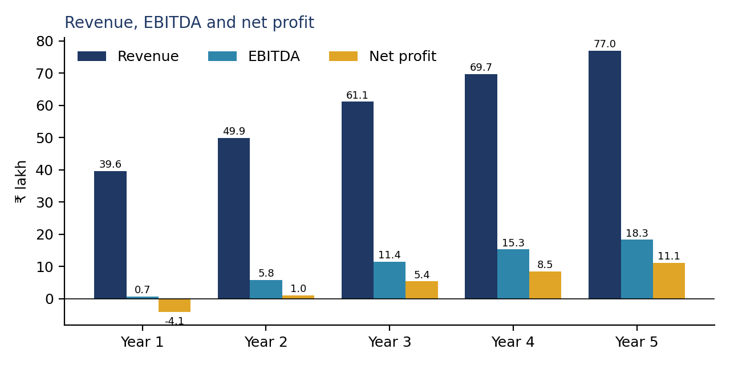
Figure 1: Revenue, EBITDA and net profit, Years 1 to 5 (₹ lakh).
Interpretation. Year 1 is the stress year: EBITDA is only ₹0.72 lakh, so after depreciation (₹3.34 lakh) and loan interest (₹1.46 lakh) the café records a net loss of ₹4.08 lakh. Profitability then builds as the customer base grows while fixed costs rise only slowly: EBITDA margin improves from 1.8% to 23.8%, and net profit reaches ₹11.13 lakh by Year 5. This operating leverage is the heart of the investment case, and also its main risk: if volume does not ramp up, the fixed cost base remains and losses persist.

7.2 Projected cash flow
₹ lakh | Year 0 | Year 1 | Year 2 | Year 3 | Year 4 | Year 5
Net profit | – | (4.08) | 0.98 | 5.39 | 8.50 | 11.13
Add: depreciation | – | 3.34 | 3.34 | 3.34 | 3.34 | 3.14
Less: increase in working capital | – | (0.10) | (0.03) | (0.03) | (0.02) | (0.02)
Operating cash flow | – | (0.85) | 4.29 | 8.70 | 11.81 | 14.25
Capex, deposit & set-up | (22.82) | – | – | – | – | –
Investing cash flow | (22.82) | – | – | – | – | –
Debt drawn | 14.65 | – | – | – | – | –
Equity introduced | 14.65 | – | – | – | – | –
Loan principal repaid | – | (2.93) | (2.93) | (2.93) | (2.93) | (2.93)
Financing cash flow | 29.30 | (2.93) | (2.93) | (2.93) | (2.93) | (2.93)
Net change in cash | 6.48 | (3.78) | 1.36 | 5.77 | 8.88 | 11.32
Closing cash | 6.48 | 2.70 | 4.06 | 9.83 | 18.71 | 30.03
Source: sheet 13_Cash_Flow.
The cash flow statement shows that the café stays solvent throughout: closing cash never falls below ₹2.70 lakh (the low point is Year 1, when losses and loan repayments coincide), and the opening cash buffer is what prevents a shortfall. Operating cash flow is slightly negative in Year 1 (−₹0.85 lakh) because the accounting loss is almost fully offset by non-cash depreciation, and it turns positive from Year 2. The ₹2.93 lakh annual principal repayment is a sizeable claim on early cash. By Year 5 the loan is fully repaid and cash stands at ₹30.03 lakh.

7.3 Projected balance sheet
₹ lakh | Year 0 | Year 1 | Year 2 | Year 3 | Year 4 | Year 5
Net fixed assets | 20.79 | 17.45 | 14.12 | 10.78 | 7.45 | 4.31
Security deposit | 2.03 | 2.03 | 2.03 | 2.03 | 2.03 | 2.03
Receivables | – | 0.22 | 0.27 | 0.33 | 0.38 | 0.42
Inventory | – | 0.27 | 0.34 | 0.42 | 0.48 | 0.53
Cash | 6.48 | 2.70 | 4.06 | 9.83 | 18.71 | 30.03
Total assets | 29.30 | 22.67 | 20.82 | 23.39 | 29.05 | 37.32
Payables | – | 0.39 | 0.49 | 0.60 | 0.69 | 0.76
Bank loan | 14.65 | 11.72 | 8.79 | 5.86 | 2.93 | –
Share capital | 14.65 | 14.65 | 14.65 | 14.65 | 14.65 | 14.65
Retained earnings | – | (4.08) | (3.10) | 2.28 | 10.78 | 21.91
Total liabilities & equity | 29.30 | 22.67 | 20.82 | 23.39 | 29.05 | 37.32
Balance check | 0.00 | 0.00 | 0.00 | 0.00 | 0.00 | 0.00
Source: sheet 14_Balance_Sheet. The balance check (assets minus liabilities and equity) is zero in every year.
The balance sheet balances in all six dates, which proves the three statements are properly linked: net profit flows to retained earnings, depreciation reduces fixed assets, loan repayments reduce debt, and closing cash comes from the cash flow statement. Retained earnings are negative in Year 1 because of the opening loss and turn positive by Year 3.

8. Project Free Cash Flow & Appraisal

8.1 Project free cash flow
Project free cash flow measures the café as a business, independent of how it is financed. It therefore starts from operating profit (EBIT), deducts tax on that profit, adds back depreciation, and subtracts investment and working-capital build-up. Interest, loan drawdown and loan repayment are excluded because their cost is already captured in the discount rate; including them would count the cost of financing twice.
₹ lakh | Year 0 | Year 1 | Year 2 | Year 3 | Year 4 | Year 5
EBIT | – | (2.62) | 2.48 | 8.08 | 11.94 | 15.17
Tax on EBIT | – | – | 0.62 | 2.03 | 3.01 | 3.82
NOPAT | – | (2.62) | 1.85 | 6.05 | 8.94 | 11.35
Add: depreciation | – | 3.34 | 3.34 | 3.34 | 3.34 | 3.14
Capex & set-up | (20.79) | – | – | – | – | –
Security deposit | (2.03) | – | – | – | – | –
Initial working capital | (6.48) | – | – | – | – | –
Increase in working capital | – | (0.10) | (0.03) | (0.03) | (0.02) | (0.02)
After-tax salvage value | – | – | – | – | – | 1.08
Release of working capital | – | – | – | – | – | 6.48
Refund of deposit | – | – | – | – | – | 2.03
PROJECT FREE CASH FLOW | (29.30) | 0.62 | 5.16 | 9.35 | 12.25 | 24.05
Cumulative FCF | (29.30) | (28.68) | (23.51) | (14.16) | (1.91) | 22.14
Source: sheet 15_Project_FCF.

8.2 Appraisal results
Metric | Result | How to read it
Required return (WACC) | 13.29% | The hurdle the project must clear
Net present value | ₹2.03 lakh | Sum of discounted cash flows minus investment; positive means value is created
Internal rate of return | 15.26% | Exceeds the hurdle by 1.97 percentage points
Payback period | 4.08 years | Time to recover the initial investment from cash flows
Profitability index | 1.07 | Each ₹1 invested returns about ₹1.07 in today's value
Source: sheet 16_Appraisal. NPV was computed two independent ways (Excel NPV function and the sum of present values) and both agree.
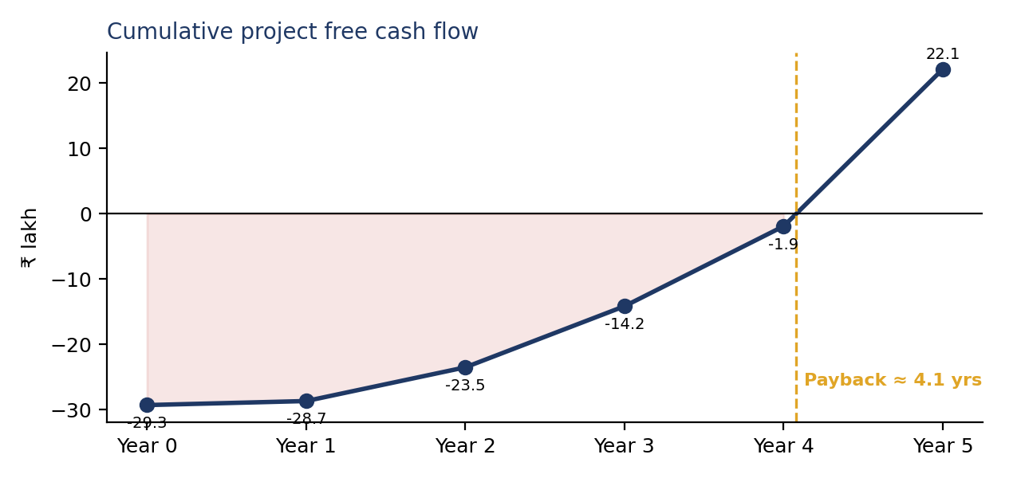
Figure 2: Cumulative project free cash flow; the line crosses zero at about 4.1 years.

8.3 What the numbers mean
The project passes the basic tests: NPV is positive and IRR is above the hurdle. But the margins are thin. The NPV of ₹2.03 lakh is only about 6.9% of the money invested, and payback takes 4.1 of the five years, so almost all the value is earned in Years 3 to 5.
One further point deserves honesty. Year 5 includes ₹9.58 lakh of terminal recoveries (resale of equipment, refund of the deposit and release of the cash buffer). Most of this is a return of money already counted as an outflow in Year 0, so including it is correct. But its present value is about ₹5.13 lakh, which is larger than the whole NPV: without these recoveries the NPV would be about −₹3.10 lakh. In plain terms, the result depends on the lease ending cleanly, the deposit being returned, and the cash buffer not being consumed by early losses. That is another reason we present this as a conditional, not an unconditional, investment.

9. Break-even Analysis
Break-even answers a practical question: how many customers must the café serve every day just to cover its fixed costs? Each customer pays a bill and uses variable cost, and the difference is the contribution that goes towards fixed costs.
Year-1 break-even | Value
Average bill per customer | ₹160
Variable cost per customer | ₹57.6
Contribution per customer | ₹102.4 (64.0% of the bill)
Annual fixed operating costs | ₹24.63 lakh
Break-even customers per year | 24,049
Break-even customers per day | 72.9
Break-even revenue per year | ₹38.48 lakh
Projected Year-1 customers per day | 75.0
Margin of safety | 701 customers a year (2.8%)
Break-even seat turns per day | 2.43
Break-even incl. depreciation and interest | 87 customers per day
Source: sheet 17_Break_Even.
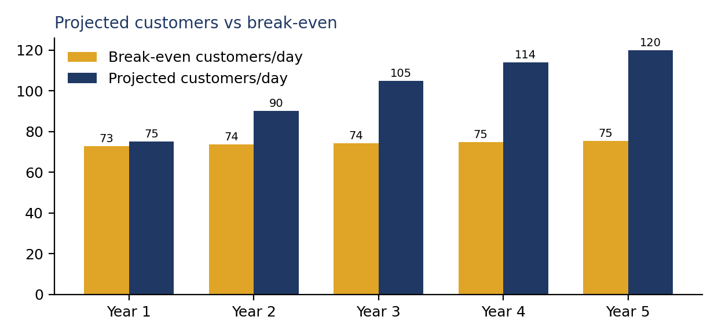
Figure 3: Projected customers per day against break-even, Years 1 to 5.
Interpretation. In Year 1 the café needs about 73 customers a day to cover its fixed costs; the plan assumes 75. That is a margin of safety of only 2.8%, so the first year is essentially a test of whether the café can reach its planned footfall immediately. The cushion widens rapidly: the margin of safety is about 18.2% in Year 2 and 37.1% by Year 5, because customer numbers grow faster than break-even. If we include depreciation and interest (a full accounting break-even), Year 1 needs about 87 customers a day, which the plan does not reach; this is why Year-1 net profit is negative.

10. Scenario & Sensitivity Analysis

10.1 Scenarios
Each scenario changes four variables together and re-runs the entire model (revenue, costs, tax, working capital, cash flow, NPV and IRR). The Year-0 investment is held at the base case, because it is committed before outcomes are known.
Scenario | Volume | Price | Variable cost | Fixed cost
Pessimistic | -20% | -10% | +10% | +10%
Base | 0% | 0% | 0% | 0%
Optimistic | +20% | +10% | -5% | -5%

Scenario | Year-1 revenue | Year-5 revenue | Year-5 EBITDA | NPV | IRR | Payback
Pessimistic | 28.51 | 55.45 | (3.03) | (48.92) | n/a | > 5 yrs
Base | 39.60 | 77.01 | 18.30 | 2.03 | 15.3% | 4.1 yrs
Optimistic | 52.27 | 101.66 | 40.61 | 46.34 | 53.8% | 2.1 yrs
Source: sheet 18_Scenarios (₹ lakh). The base scenario reproduces the model NPV exactly (check passes).
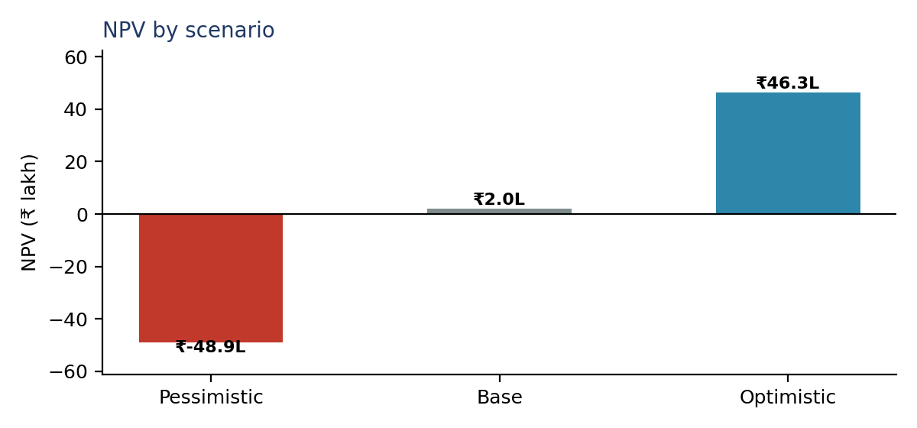
Figure 4: NPV under the pessimistic, base and optimistic scenarios.
Interpretation. The outcomes are very asymmetric. The optimistic case produces an NPV of ₹46.34 lakh and a payback near 2.1 years, but the pessimistic case produces an NPV of −₹48.92 lakh with an operating loss in Year 5 (EBITDA −₹3.03 lakh). The reason is operating leverage: with fixed costs of ₹24.6 lakh in Year 1, a combined fall in volume and price removes the whole contribution margin. We did not model the owner closing the café early to stop losses, so the pessimistic NPV overstates the true loss; but it correctly signals that a bad outcome is far larger than the base-case gain.

10.2 Sensitivity
Sensitivity changes one variable at a time by ±10% and ±20%, holding the others at base. The table shows NPV in ₹ lakh.
Variable | −20% | −10% | Base | +10% | +20%
Selling price | (32.03) | (14.23) | 2.03 | 17.50 | 32.39
Sales volume | (18.93) | (8.21) | 2.03 | 12.13 | 21.68
Variable cost | 13.32 | 7.70 | 2.03 | (3.64) | (9.53)
Fixed cost | 16.91 | 9.73 | 2.03 | (5.69) | (13.90)
Discount rate | 5.08 | 3.51 | 2.03 | 0.64 | (0.67)
Source: sheet 19_Sensitivity (NPV, ₹ lakh). Discount-rate row flexes the WACC by ±10% and ±20% of its value.
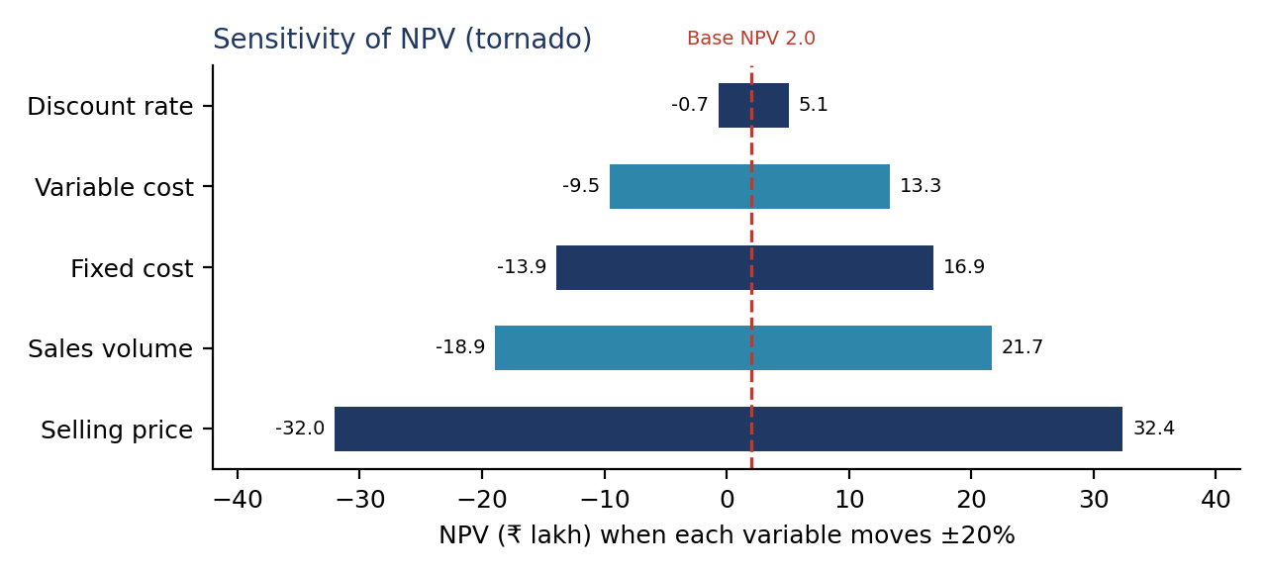
Figure 5: Tornado chart. The wider the bar, the more that variable moves NPV.

10.3 Which variables matter most
Ranked by swing in NPV, Selling price is the most sensitive variable, followed by sales volume, variable cost, fixed cost and finally the discount rate. A useful way to read this is how far each variable can move against us before the NPV reaches zero:
- Selling price: NPV turns negative if prices are only about 1.2% lower than planned.
- Sales volume: NPV turns negative if customers are about 2.0% fewer than planned.
- Fixed costs: NPV turns negative if fixed costs are about 2.6% higher (for example, rent or payroll).
- Variable cost: NPV turns negative if food and packaging costs are about 3.6% higher.
These cushions are small. The discount rate matters least, so the uncertainty in our cost-of-capital assumptions is not the main concern; the real uncertainty sits in price, footfall and costs, which is why those are the inputs we propose to firm up first.

11. Investment Recommendation
Decision: Invest with Conditions.

11.1 Why not an unconditional "Invest"
- The base case clears both tests (NPV ₹2.03 lakh > 0; IRR 15.3% > 13.3%), so the project is not a clear rejection.
- The margin is thin: profitability index 1.07, IRR cushion of 2.0 points, payback 4.1 years, and Year-1 customers only 2.8% above break-even.
- The downside is large: pessimistic NPV −₹48.92 lakh, and a price, volume or cost miss of only a few percent erases the base-case NPV.
- Most key inputs (rent, capex, average bill, turns) are estimates, not quotations.

11.2 Why not "Do Not Invest"
Operating performance improves strongly with scale, the café stays solvent throughout with the planned cash buffer, the loan is repaid inside the horizon, and the optimistic case is attractive. Rejecting outright would ignore a project that plausibly earns above its cost of capital. The right response to a thin, uncertain case is to reduce the uncertainty before committing.

11.3 Conditions for proceeding
# | Condition | Threshold / test | Why it matters
1 | Firm up rent and capex with real quotes | Rent ≤ ₹90/sq ft; equipment, furniture, fit-out and POS ≤ ₹18.3 lakh combined | Fixed cost +2.6% or more removes the NPV
2 | Confirm the average bill from local competitor menus | Achievable average bill ≥ ₹160 before GST | Price is the most sensitive variable
3 | Validate demand before full fit-out | Evidence of ≥ 75 customers/day potential (footfall count, competitor occupancy) | Break-even is 73/day; cushion is small
4 | Control early costs | Hold staff at five; negotiate rent-free fit-out period or escalation | Fixed costs drive the early losses
5 | Monitor after opening | Review monthly; trigger a formal reassessment if customers/day stay below 73 for three consecutive months | Limits the time spent in the loss zone
6 | Pursue upside levers | Seek any available MSME/start-up support; test a higher-margin menu mix | Raises the cushion without raising risk
Source: derived from sheets 16_Appraisal, 17_Break_Even and 19_Sensitivity.

11.4 What would change the decision
- To "Invest": documented quotes at or below the assumed costs, an average bill above ₹160, and evidence of footfall comfortably above 75 customers a day, so that the pessimistic NPV is no longer negative.
- To "Do Not Invest": rent or capex well above the assumptions, evidence that competitors already saturate the local market, or an achievable average bill materially below ₹160.

12. Risks & Limitations

12.1 Risks
Risk | Type | Effect | Mitigation
Footfall below plan (semester breaks, competitor opening) | Commercial | Revenue and break-even; fixed costs unchanged | Pre-opening footfall check; student offers; flexible opening hours
Price pressure from nearby cafés and food platforms | Commercial | Lower average bill; most sensitive variable | Value combos; avoid deep discounting; monitor competitor menus
Food cost inflation and wastage | Operational | Variable cost above 36% | Weekly inventory, small menu, supplier comparison
Rent escalation or lease termination | Operational | Fixed cost rise; fit-out stranded | Five-year lease with capped escalation
Staff turnover and service quality | Operational | Lost customers; higher wages | Pay above minimum; training; owner-manager presence
Loan repayment in the loss-making early years | Financial | Cash stress in Year 1 | Opening cash buffer; moratorium negotiation
Interest and discount rate rises | Financial | Lower NPV; higher interest | Fixed-rate loan; keep leverage at 50%
Regulatory (FSSAI, fire, local approvals) | Compliance | Delay or closure | Obtain licences before fit-out

12.2 Limitations of the model
- Estimated inputs. Rent, capex, average bill, food cost and utilisation are estimates; they are flagged in the workbook and tested in sensitivity, but not replaced by quotations.
- Single outlet, averaged seasonality. The model uses annual averages and does not capture month-by-month swings tied to the academic calendar.
- GST and platform commissions. Revenue is shown before GST. Commissions on food-delivery platforms are not modelled separately.
- No loss carry-forward and no early exit. Both are conservative simplifications; the second makes the pessimistic scenario look worse than a real owner would allow.
- Competition and cannibalisation are not modelled explicitly; they are reflected only through the volume and price sensitivities.
- Terminal value is conservative (25% resale, no goodwill), which may understate a successful café.

13. References
SRC-01 WageIndicator (2026). Minimum Wage, Punjab: Shops and Commercial Establishments Act schedule, effective 1 May 2026. wageindicator.org/en-in/ai/work-in-india/minimum-wage/20772-punjab/
SRC-02 The Tribune. No change in power tariff for domestic, commercial users (PSERC tariff order FY2025-26). tribuneindia.com
SRC-03 Babushahi / The Fact News. PSERC tariff order for FY2026-27 (6 March 2026). babushahi.com
SRC-04 Reserve Bank of India. Monetary Policy Committee decision, August 2026 (repo rate 5.25%); 5paisa summary of MPC schedule. 5paisa.com/blog/rbi-mpc-meeting-schedule
SRC-05 Trading Economics (15 September 2026). India 10-year yield climbs to near four-month high. tradingeconomics.com/india/government-bond-yield
SRC-06 Trading Economics (CPI, August 2026) and Akashvani (RBI first bi-monthly policy statement, FY2026-27). newsonair.gov.in
SRC-07 Careers360. Location of LPU Phagwara in Punjab (student strength, GT Road). careers360.com
SRC-08 Income Tax Department, Government of India. Concessional corporate tax regime, Section 115BAA. incometax.gov.in
SRC-09 FSSAI FoSCoS portal. Licence and registration fees. foscos.fssai.gov.in
SRC-10 General restaurant-industry cost benchmarks (food cost 28–35% of sales; supplier credit terms). Estimation basis.
SRC-11 IndiaMART supplier listings (café equipment, furniture, fit-out price ranges). indiamart.com. Estimation basis.
SRC-12 Local commercial rental market near LPU / GT Road (property listings). Estimation basis.
SRC-13 Zomato / Swiggy menus of cafés near LPU. Estimation basis.
SRC-14 Damodaran, A. Country risk premiums and CAPM inputs. pages.stern.nyu.edu/~adamodar/
SRC-15 State Bank of India. MSME term-loan terms. sbi.co.in. Estimation basis.
Entries marked "Estimation basis" were not formally cited as a single document; they are documented as estimates in the workbook with a suggested way to firm them up.

14. Appendix

A. Quality assurance checks
The workbook contains automatic checks (sheet 22_QA_Viva). All twelve returned PASS at the time of writing.
Check | Result
Funding equals investment | PASS
Balance sheet balances in every year | PASS
Debt fully repaid by end of tenor | PASS
Depreciation in income statement equals asset schedule | PASS
Closing cash equals balance-sheet cash | PASS
Project FCF starts from EBIT (excludes interest and loan flows) | PASS
NPV and IRR use the same FCF series | PASS
NPV formula agrees with sum of present values | PASS
Scenario base case equals model NPV | PASS
Sensitivity base column equals model NPV | PASS
Dashboard NPV equals appraisal NPV | PASS
Contribution per customer is positive | PASS

B. Present-value calculation
 | Year 0 | Year 1 | Year 2 | Year 3 | Year 4 | Year 5
Project FCF (₹ lakh) | (29.30) | 0.62 | 5.16 | 9.35 | 12.25 | 24.05
Discount factor at 13.29% | 1.0000 | 0.8827 | 0.7791 | 0.6877 | 0.6070 | 0.5358
Present value (₹ lakh) | (29.30) | 0.55 | 4.02 | 6.43 | 7.44 | 12.89
Sum of present values = NPV = ₹2.03 lakh. Source: sheet 16_Appraisal.

C. Workbook map
Sheets | Contents
00–03 | Cover, project definition, data and source register, AI research log
04 | Assumption register (all inputs, with source, rationale and "if wrong" note)
05–11 | Operating drivers, investment and funding, revenue, costs, depreciation, debt, working capital
12–14 | Income statement, cash flow statement, balance sheet
15–16 | Project free cash flow; NPV, IRR, payback and decision
17–19 | Break-even, scenarios, sensitivity
20–22 | Dashboard, report outline, QA checks and viva preparation

D. AI research log (summary)
Date | Tool | Task | Verification
30/09/2026 | Claude (Anthropic) | Explained the assignment brief; compared project options | Checked against the faculty manual; EV hub rejected as too complex
30/09/2026 | Claude (Anthropic) | Searched Punjab minimum wages | Matched to WageIndicator reproduction of the state notification
30/09/2026 | Claude (Anthropic) | Searched PSERC commercial electricity tariff | Matched to The Tribune and Babushahi reports; conservative ₹7.2 used
30/09/2026 | Claude (Anthropic) | Searched repo rate, 10-year yield, CPI | Matched to RBI/5paisa and Trading Economics
30/09/2026 | Claude (Anthropic) | Built the linked Excel model structure | Twelve automatic checks pass; estimated inputs flagged, not presented as facts
Source: sheet 03_AI_Research_Log. Add any other tool use by group members.

